Corrections Service Opportunity
Butner Federal Correctional Institution
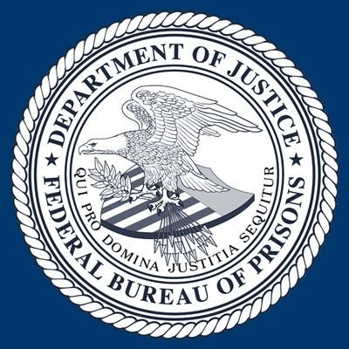
After almost 3 years away from this facility, consider being part of rejoining and revisioning of AA service through carrying the message behind the walls at Butner Federal Prison. The district has shared experience, strength, and hope with inmates for many years. There have been up to six weekly meetings at five different settings including one of the 12 federal prison hospital units. There is an application and background screening process for all volunteers.
The Application to provide services, Release of information, NCIC check form, and an explanation of Letter of Endorsement/Reference are required to serve at this facility. We highly recommend the letters of endorsement/reference are completed and turned in at training or prior to training. Two letters of reference are required prior to or on the date of training. Since all the volunteers are representing the AA organization it would suffice for each person to provide a letter of endorsement from the AA organization. The letter needs to be written on the organizations letterhead and the volunteer must be in good standing with the sponsoring organization. The letter does need to include the volunteer’s first and last name. The letter will be stored in our volunteer folder, which is maintained by me and is treated with the same security as the NCIC forms. All of the information provided is only accessible by staff, no inmates will have access to any of this information. Also, the letters can be e-mailed to me to expedite the process. All forms can be e-mailed to me or brought to training.

2023 Training Dates (4 hours w/PREA training)

April 12 Wednesday 12-4
May 12 Friday 12-4
June 22 Tuesday 8-12
July 25 Tuesday 8-12
September 18 Monday 8-12
November 3 Friday 12-4
December 6 Wednesday 12-4

To register for training, please contact

Michael Mechalske, Re-Entry Affairs Coordinator
FCC Butner
919-575-5000 ext 1405 mmechalske@bop.gov

